LAB 5 :
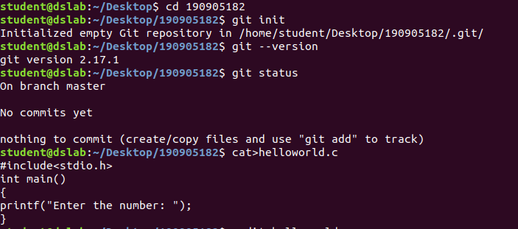
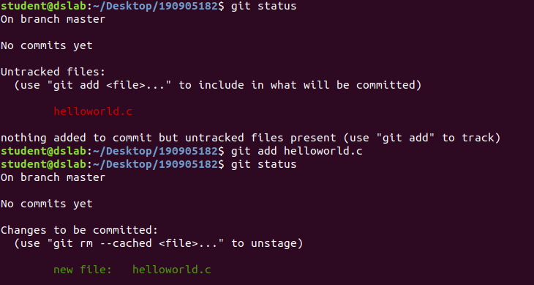
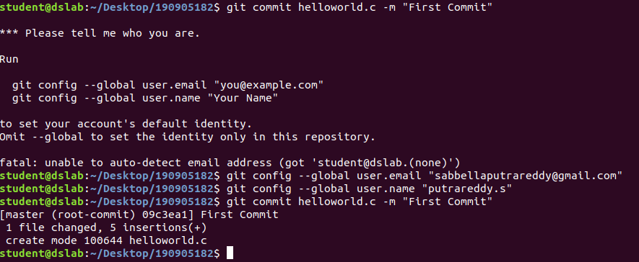
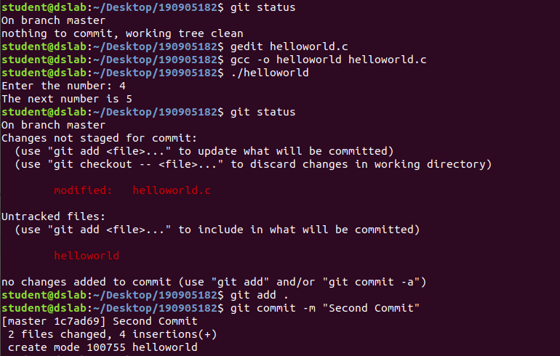
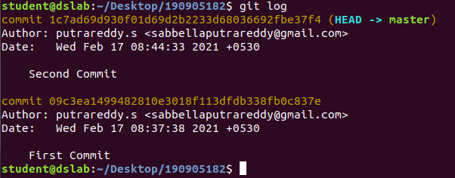

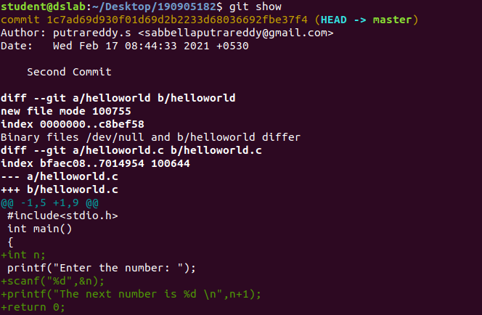
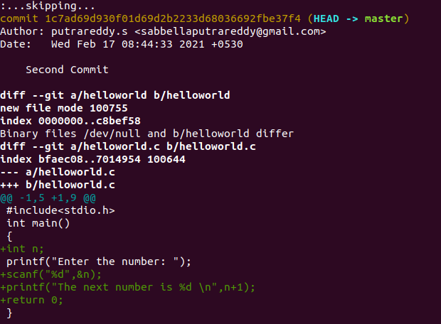

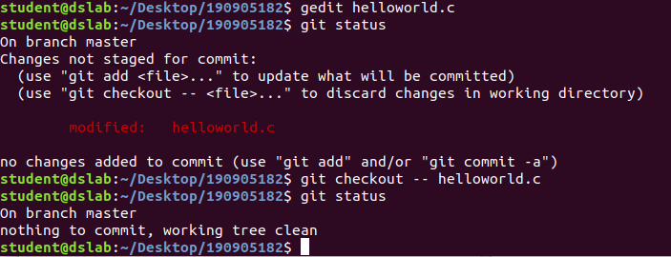
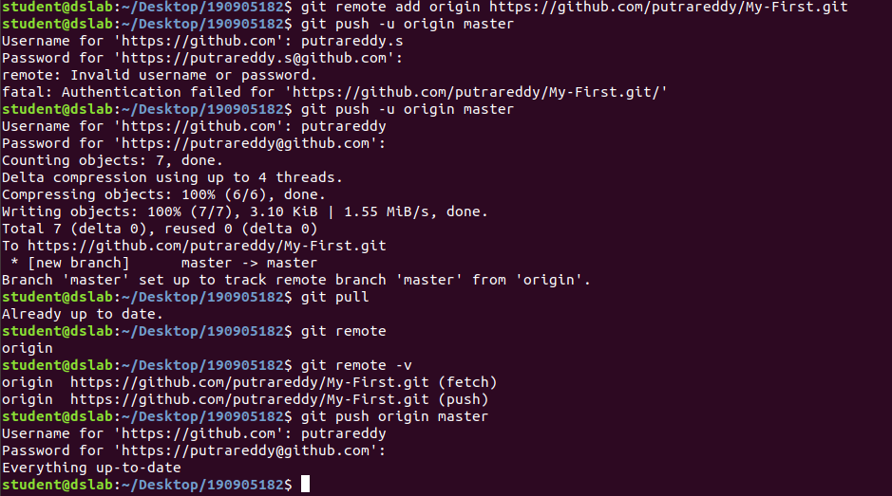
LAB 6

9.
<html>
<head>OST Lab</head>
<title>HTML</title>
<style>
.myDiv
{
text-align: center;
}
</style>
<body>
<h1>Heading 1</h1>
<h2>Heading 2</h2>
<h3>Heading 3</h3>
<h4>Heading 4</h4>
<h5>Heading 5</h5>
<h6>Heading 6</h6>
<p>This is a paragraph with <br>line breaks</br></p>
<p><b>This is bold</b></p>
<p><i>This is italic</i></p>
<pre>This is preformmated text with <br></br>line breaks</pre>
<p>This is <del>deleted</del> and <ins> inserted </ins>text</p>
<p style="direction: rtl;">This text will be from right to left</p>
<p>This is an example of <span style="color: blue;font-weight:bold">span</span></p>
<div class="myDiv"><p>This is some text in div</p></div>
<p>This is outside div</p>
</body>
</html>

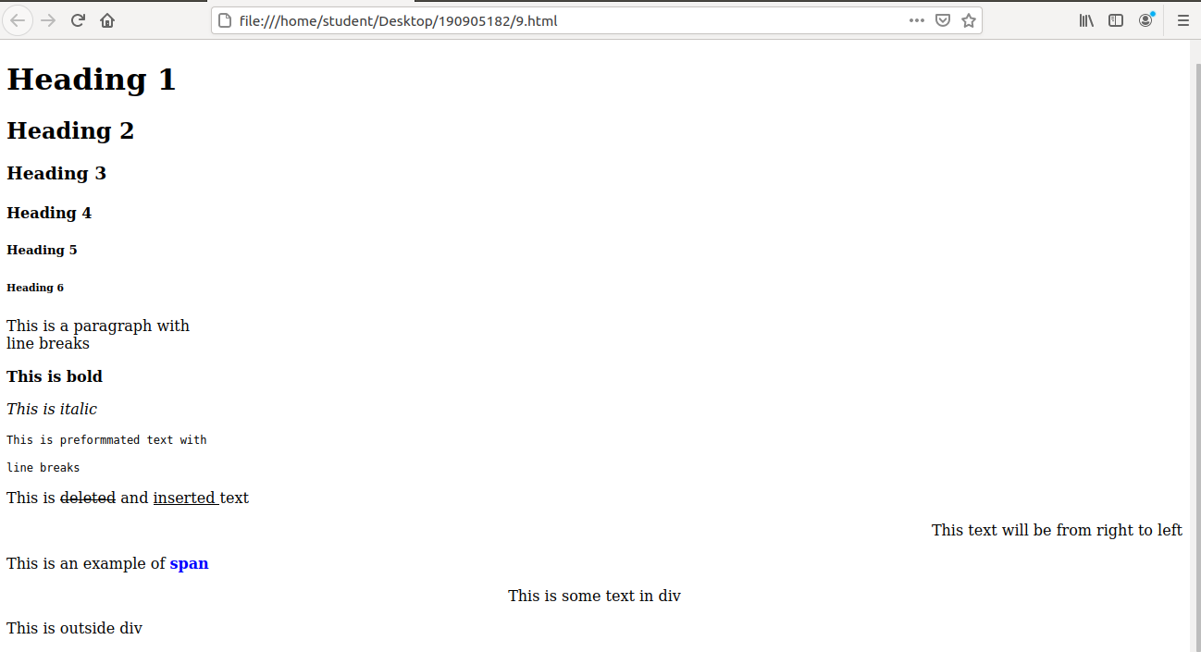
10&11.
<html>
<head>OST Lab2</head><br></br>
<title>HTML2</title>
<body>
<a href ="https://manipal.edu/mu.html">Manipal University</a>
</body>
</html>
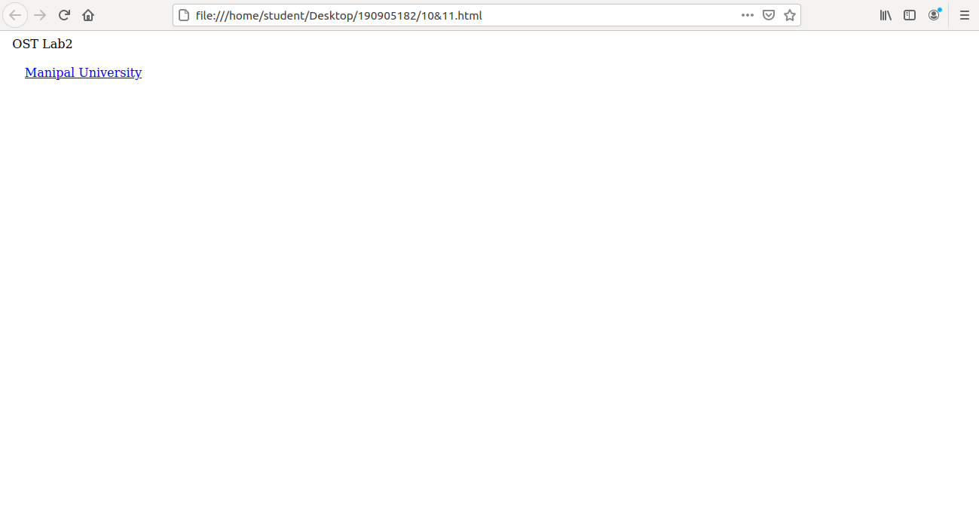

(ii)
<html>
<head>OST Lab2</head>
<br></br>
<title>HTML2</title>
<body>
<a href ="https://manipal.edu/mu.html">Manipal University<img src="manipal.jpeg" alt =
"MAHE" width = 200 height = 200></a>
</body>
</html>

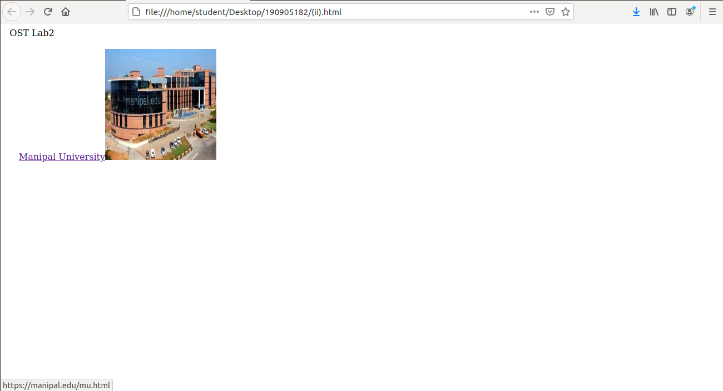
(iii)
<html>
<head>OST Lab2</head>
<br></br>
<title>HTML2</title>
<body>
<a href ="https://manipal.edu/mu.html">Manipal University<img src="manipal.jpeg" alt =
"MAHE" width = 200 height = 200></a>
<a href ="https://manipal.edu/mu.html" target=_blank>Manipal University in a new
tab</a>
</body>
</html>
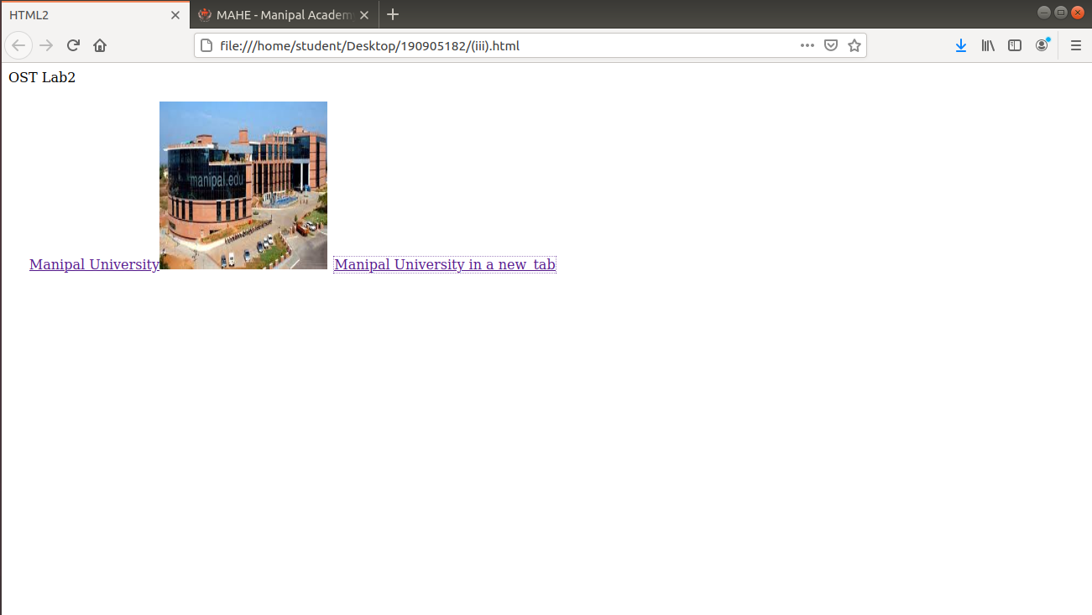
12.
<html>
<head>
<title>HTML Table</title>
<style>
table, th, td {
border: 1px solid black;
}
</style>
</head>
<body>
<table style="width: 100%">
<caption> Details </caption>
<tr>
<th>Firstname</th>
<th>Lastname</th>
<th>Age</th>
</tr>
<tr>
<td>s</td>
<td>putra</td>
<td>19</td></tr>
<tr>
<td>s</td>
<td>suhas</td>
<td>13</td>
</tr>
</table>
</body>
</html>
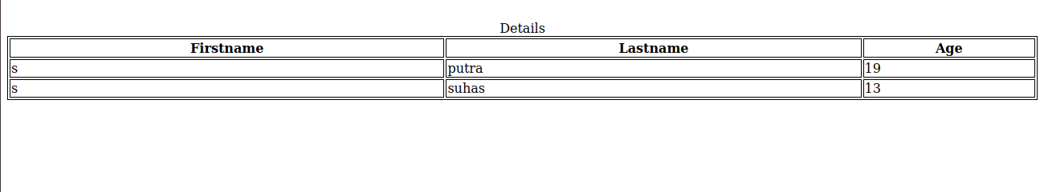
<html>
<head>
<title>HTML Table</title>
<style>
table, th, td {
border: 1px solid black;
}
</style>
</head>
<body>
<table style="width: 100%">
<caption> Details </caption>
<tr>
<th>Firstname</th>
<th colspan = "3">Children</th>
</tr>
<tr>
<td>putra</td>
<td>suhas</td>
<td>sirisha</td>
<td>bhargav</td>
</tr>
</table>
</body>
</html>
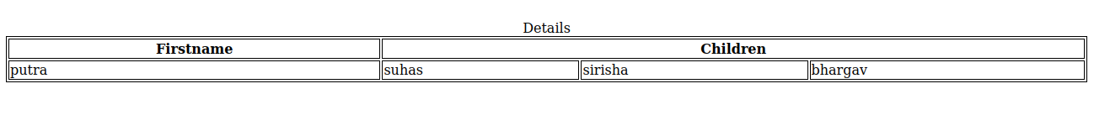
<html>
<head>
<title>HTML Table</title>
<style>
table, th, td {
border: 1px solid black;
}
</style>
</head>
<body>
<table style="width: 100%">
<caption> Details </caption>
<tr>
<th>Firstname</th>
<td>Rakesh</td>
</tr>
<tr>
<th rowspan = "3">Children</th>
<td>Deeksha Misri</td>
</tr>
<tr>
<td>Tanvi Misri</td>
</tr>
<tr>
<td>Megha Misri</td>
</tr>
</table>
</body>
</html>
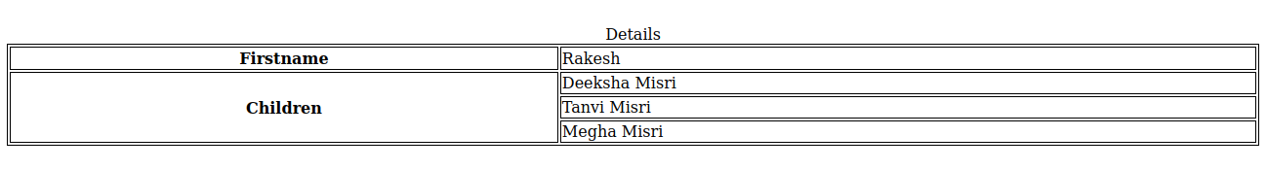

13.
<html>
<head>OST Labs</head>
<title>Lists</title>
<body>
<ol>
<li>Chocolate</li>
<li>juice</li>
<li>cake</li>
</ol>
</body>
</html>
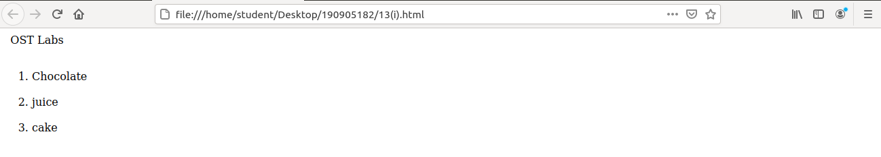
<html>
<head>OST Labs</head>
<title>Lists</title>
<body>
<ul>
<li>Chocolate</li>
<li>juice</li>
<li>cake</li>
</ul>
</body>
</html>
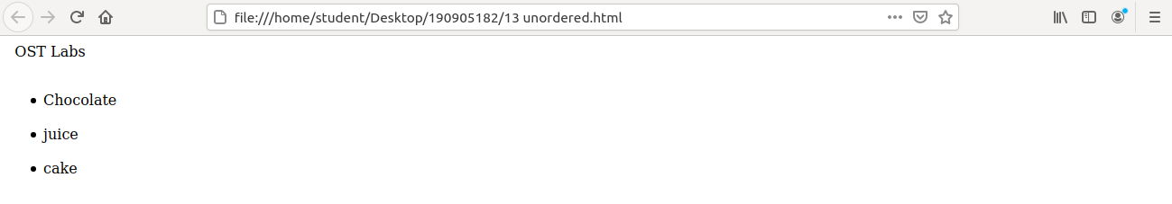
<html>
<head>OST Lab</head>
<title>Lists</title>
<body>
<dl>
<li>Cake</li>
<dd>juice</dd>
<li>Coke</li>
<dd>Sprite</dd>
<li>Lays</li>
<dd>Chocolate</dd>
</dl>
</body>
</html>

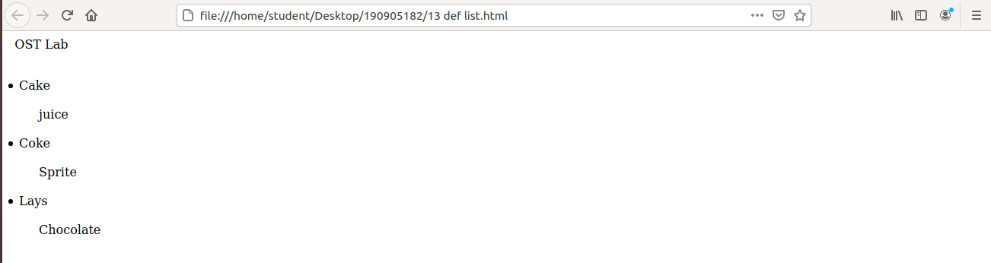
14.
<html>
<head>OST Lab</head>
<title>Forms</title>
<body>
<form>
<fieldset>
<label for="fname">First Name:</label><br>
<input type="text" id ="fname" name="fname"><br>
<label for="lname">Last Name:</label><br>
<input type="text" id ="lname" name="lname"><br>
<label for="pwd">Password:</label><br>
<input type="password" id ="pwd" name="pwd"><br>
<input type="radio" id ="male" name="gender" value="male">
<label for="male">Male</label><br>
<input type="radio" id ="female" name="gender" value="female">
<label for="female">Female</label><br>
<input type="radio" id ="others" name="gender" value="others">
<label for="others">Others</label><br>
<input type="checkbox" id ="vehicle1" name="vehicle1" value="Bike">
<label for="vehicle1">I have a Bike</label><br>
<input type="checkbox" id ="vehicle2" name="vehicle2" value="Car">
<label for="vehicle2">I have a Car</label><br>
<input type="checkbox" id ="vehicle3" name="vehicle3" value="Plane">
<label for="vehicle3">I have a Plane</label><br>
<label for="Food">Choose Food:</label><select name="Food" if="Food">
<option value="Cake">Cake</option>
<option value="Coke">Coke</option>
<option value="Lays">Lays</option>
</select>
<br></br>
<button type="Submit" value="Submit">Submit</button>
<button type="Reset" value="Reset">Reset</button>
</fieldset>
</form>
</body>
</html>

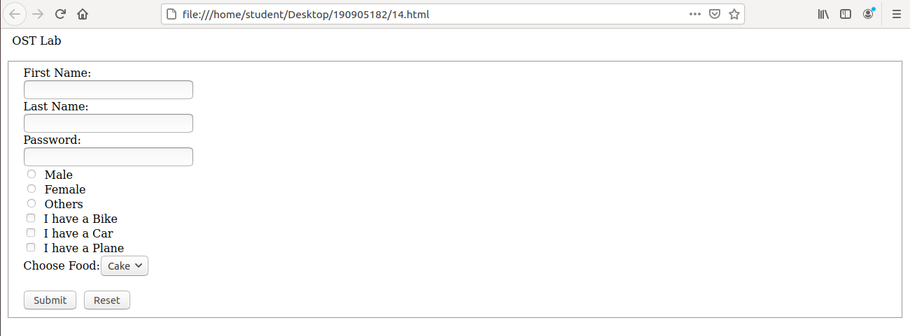
15.
<html>
<head>OST Lab</head>
<title>Forms</title>
<body>
<h1 style="color:blue;text-align: center;">Heading</h1>
<p style="color:red;">Paragraph</p>
</body>
</html>
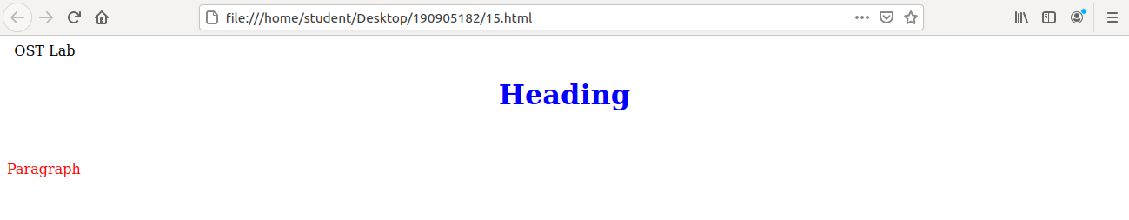
16.
<html>
<body>
<canvas id="myCanvas" width="300" height="150" style="border:1px solid #d3d3d3;">
Your browser does not support the HTML5 canvas tag.</canvas>
<script>
var c = document.getElementById("myCanvas");
var ctx = c.getContext("2d");
ctx.beginPath();
ctx.rect(20, 20, 150, 100);
ctx.stroke();</script>
</body>
</html>
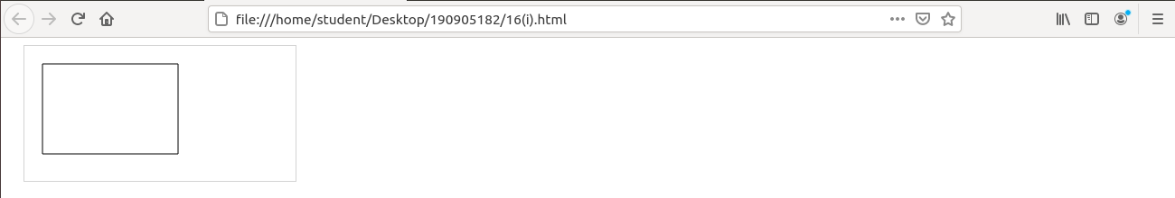

<html>
<body>
<canvas id="myCanvas" width="200" height="100" style="border:1px solid #d3d3d3;">
Your browser does not support the HTML canvas tag.</canvas>
<script>
var c = document.getElementById("myCanvas");
var ctx = c.getContext("2d");
ctx.moveTo(0,0);
ctx.lineTo(200,100);
ctx.stroke();
</script></body>
</html>
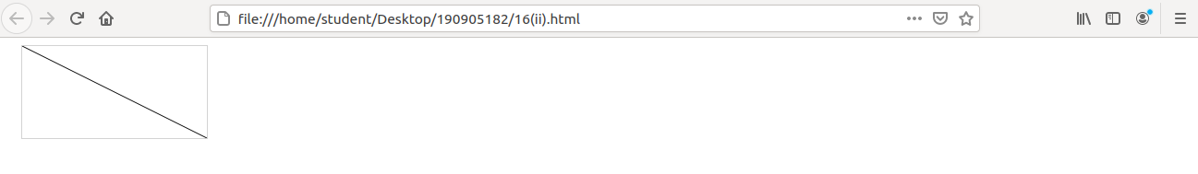
<html>
<body>
<canvas id="myCanvas" width="200" height="100" style="border:1px solid #d3d3d3;">
Your browser does not support the HTML canvas tag.</canvas>
<script>
var c = document.getElementById("myCanvas");
var ctx = c.getContext("2d");
ctx.beginPath();
ctx.arc(95,50,40,0,2*Math.PI);
ctx.stroke();
</script>
</body>
</html>
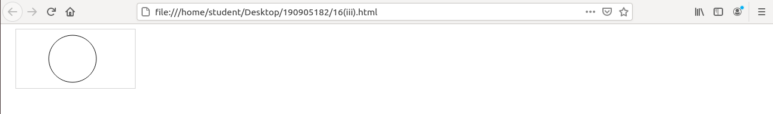
<html>
<body>
<canvas id="myCanvas" width="300" height="150" style="border:1px solid #d3d3d3;">
Your browser does not support the HTML5 canvas tag.</canvas>
<script>
var c = document.getElementById("myCanvas");
var ctx = c.getContext("2d");
ctx.beginPath();
ctx.arc(100, 75, 50, 0, 0.5 * Math.PI);
ctx.stroke();
</script>
</body>
</html>

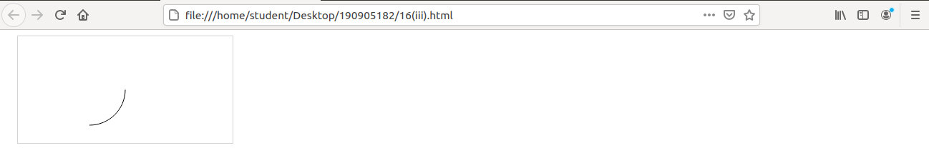
<html>
<body>
<canvas id="myCanvas" width="200" height="100" style="border:1px solid #d3d3d3;">
Your browser does not support the HTML canvas tag.</canvas>
<script>
var c = document.getElementById("myCanvas");
var ctx = c.getContext("2d");
var grd = ctx.createLinearGradient(0,0,200,0);
grd.addColorStop(0,"red");
grd.addColorStop(1,"white");
ctx.fillStyle = grd;
ctx.fillRect(10,10,150,80);
</script>
</body>
</html>
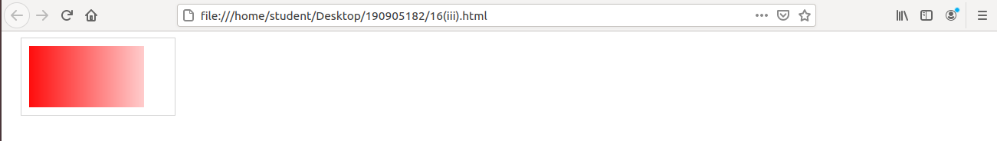
<html>
<body>
<canvas id="myCanvas" width="200" height="100" style="border:1px solid #d3d3d3;">
Your browser does not support the HTML canvas tag.</canvas>
<script>
var c = document.getElementById("myCanvas");
var ctx = c.getContext("2d");
var grd = ctx.createRadialGradient(75,50,5,90,60,100);
grd.addColorStop(0,"red");
grd.addColorStop(1,"white");
ctx.fillStyle = grd;
ctx.fillRect(10,10,150,80);
</script></body>
</html>

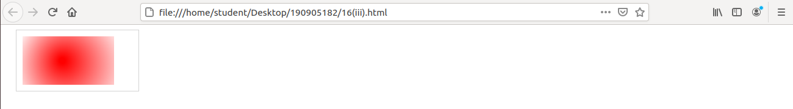
<html>
<body>
<canvas id="myCanvas" width="300" height="150" style="border:1px solid #d3d3d3;">
canvas.</canvas>
<script>
var c = document.getElementById("myCanvas");
var ctx = c.getContext("2d");
ctx.lineWidth = 10;
ctx.strokeRect(20, 20, 80, 100);
</script>
</body>
</html>
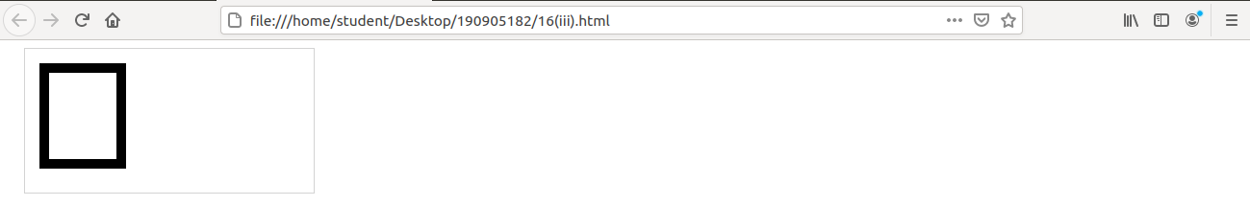
<html>
<body>
<canvas id="myCanvas" width="300" height="150" style="border:1px solid #d3d3d3;">
Your browser does not support the HTML5 canvas.</canvas>
<script>
var c = document.getElementById("myCanvas");
var ctx = c.getContext("2d");
ctx.strokeStyle = "#239505";
ctx.strokeRect(20, 20, 150, 100);
</script>
</body>
</html>
